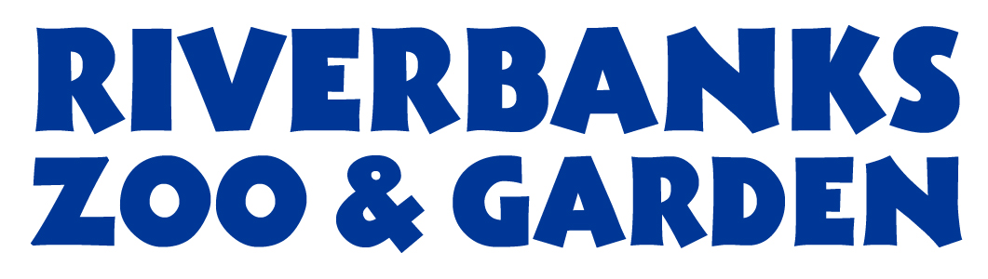
Procurement Services
400 Rivermont Drive, Columbia, SC 29210
Phone: 803-602-0835 Fax: 803-771-8722

INTENT TO AWARD
Posting Date: August 17, 2023

Solicitation: P2023-07-04

Project Title: Komodo Dragon Exhibit and Holding Complex

Awarded To: Boyer Commercial Construction

Amount of Award: $ $ 2,098,258

This is an INTENT TO AWARD and becomes the official Statement of Award contingent upon Richland-Lexington Riverbanks Parks Commission approval unless otherwise rescinded.

An actual bidder who is aggrieved in connection with the intended award or award of a contract shall protest to the Procurement Officer in writing within seven (7) calendar days of the date of Intent to Award notice. Protest letter shall state the issues of the protest, specifically listing where the District failed in determining the potential award.

The Contractor should not perform work on or incur any costs associated with the contract prior to the effective date of the contract. Contractor should not perform any work prior to the receipt of a purchase order from the using governmental unit. The District assumes no liability for any expenses incurred prior to the effective date of the contract and issuance of a purchase order.

Ashley Harris,
Ashley Harris
Vice President of Finance

