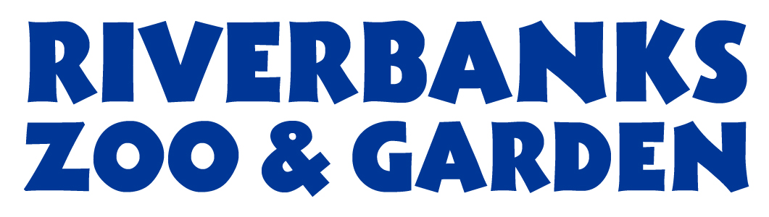
Procurement Services
400 Rivermont Drive, Columbia, SC 29210
Phone: 803-602-0831 Fax: 803-771-8722

This is an INTENT TO AWARD and becomes the official Statement of Award contingent upon Richland-Lexington Riverbanks Parks Commission approval unless otherwise rescinded.

Solicitation Number: B18002-5/30/2018

Procurement: Minor Renovations
LOT 2 (Discovery) - $10,430.00
LOT 3 (Admin) - $4,550.00

Issue Date: May 30, 2018

Closing Date: June 26, 2018

AWARD(S) ARE MADE TO THE FOLLOWING:

Ullman Construction

An actual bidder who is aggrieved in connection with the intended award or award of a contract shall protest to the Procurement Manager in writing within seven (7) calendar days of the date of Intent to Award notice. Protest letter shall state the issues of the protest, specifically listing where the District failed in determining the potential award.

Jessica Monts,
Procurement Manager

Posted: July 6, 2018

